LTE standarts
LPWA – low-power wide area, long range connection for low power devices.
MNO – mobile network operator.
3GPP – group of organizations, which standartise mobile networks.
eDRX - extended Discontinuous Reception, feature for power saving.
PS – power saving, low power mode(in addition to eDRX).
OTDOA - observed time difference of arrival, feature to estimate device’s location.
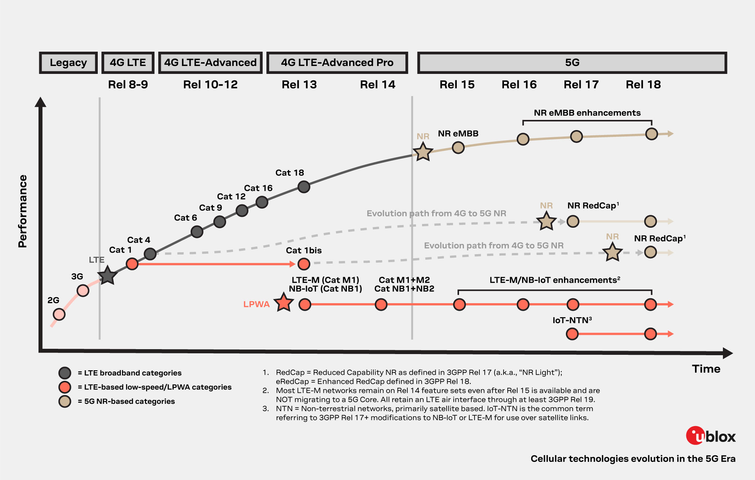
LTE NB1 and NB2 – narrow bandwidth(200kHz) standarts, for sensors, NB1 – breaks communication when reconnects between cells, NB2 – reconnects without communication loss. Speed around 250kbps.
https://www.u-blox.com/en/technologies/narrowband-iot-nb-iot

LTE M1 and M2 – also low power, with wider bandwidth(1.4MHz). Reconnects between cells without communication loss. Supports calls(VoLTE).
https://www.u-blox.com/en/technologies/lte-cat-m

LTE Cat 1, 4, … - “ussual” mobile network. Cat 1 is most commonly used.
https://www.u-blox.com/en/technologies/lte-cat-1
LTE Cat 1bis – similar performance to Cat 1 but with 1 antenna, requires separate support by operator.

LTE-FDD B1,B2, … - specification of frequency band:
https://en.wikipedia.org/wiki/LTE_frequency_bands

